EMORY UNIVERSITY

History 203-00C
The West in the World

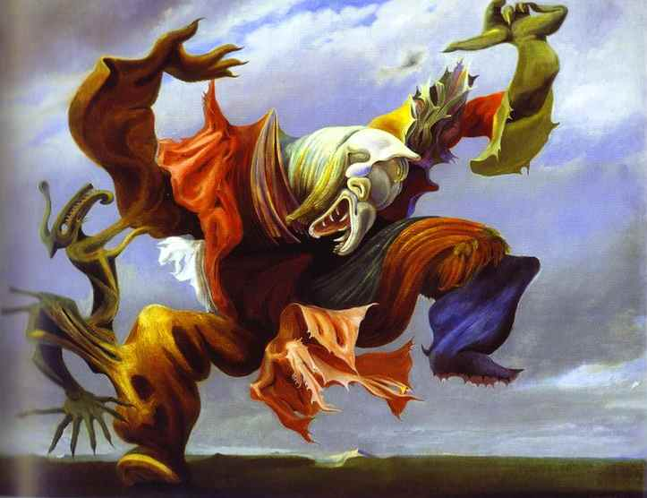

MoTuWeThFr: 10:00PM - 11:20 am
Bowden 118
Summer 2014

Prof. Matt Payne
119 Bowden
Office Hours: Wednesday, 1:00-3:00
mpayn01@emory.edu

Overview

This course will concentrate on the emergence and consequences of Europe’s rise to and decline from global hegemony in the half millennium from 1500-2000. This class will explore the causes and consequences of this historical trajectory with the emphasis on Europe, rather than the world. In other words, this is not a “world history” course but a history of Europe in the world. Discrete topics such as the medieval roots of European expansionism, the age of discovery, commodities and Empire, the impact of Revolution, the “new” Imperialism, world wars, the Cold War and decolonization are all addressed. Although different topics will highlight different European countries, the texts and lectures will try to take a broad view of the topic. As a course that serves a General Education Requirement (HSC), it is not intended to be a preparation course for later European history courses nor does it presume that students have knowledge of the topic. It is hoped, however, that the students having completed the course will be able to critically read historical primary sources, analyze them in context, and express this analysis cogently using the historical method. For this reason, reading, discussion and exposition is emphasized in this class.

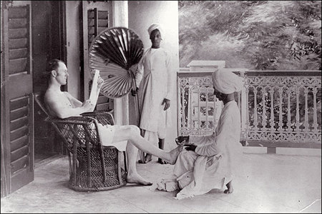

Requirements and Grading

This course requires the fulfillment of all class assignments, attendance of class, and participation in class activities. Class assignments will include weekly learn-link discussion questions, exams on class readings and quizzes.

Grading:
The grading is broken down as follows:
- Quizzes, attendance and participation: 10%
- Weekly discussion question responses: 25%
- Mid-term take-home exam: 30%
- Final take-home exam: 35%
Grading is not done on a curve but based on individual mastery of the concepts and skills highlighted in the course. These are a combination of understanding historical methodology, ability to engage in sustained critical reading, proficiency in historical analysis and skill with written exposition. Both content and style are graded. I will discuss in class and provide a handout that details my grading policy.

Assignments:
- Quizzes will normally be very short identifications to test knowledge of the textbook.
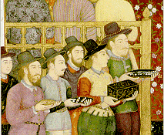
- Unit discussion responses will be required to be posted by 9:00 p.m. in the evening prior to the unit discussion class. Each unit students will chose one from several questions (usually focused on the principal reading) to discuss in two to three well-crafted paragraphs. Successful answers will provide specific information garnered from the texts we have read. Unless otherwise noted, internet resources, encyclopedias, etc. are NOT to be used (especially Google and Wikipedia). The discussion questions will be given two points for a well-argued, well supported answer; one point for an answer deficient in either of these areas and a zero for deficiencies in both. Answers posted late will receive an automatic zero.
- The mid-term take-home will be handed out on Friday, July 18th. It will consist of two potential essay questions of which students will answer one. The essay should be five-to-seven pages in length and will be due, via Blackboard (Safe-Assign), by 10:00 am on Monday, July 21st.
- The final exam will be a take-home essay exam will be handed out on Friday, August 1st. It will consist of three potential essay questions of which students will answer two. Each should be five to seven pages in length. The exam will be due, via Blackboard (Safe-Assign), on the day of our final exam, Friday, August 8th, at 11:00 am.

Course Policies
Absences and Make-Up Policy: Class attendance is mandatory and unexcused absences will be detrimental to the class participation grade (five unexcused absences will lead to automatic failure in the classroom participation grade, while each unexcused absence will lead to a loss of a grade on it). Moreover, missed assignments may not be made up without permission of the instructor. Excused absences include emergencies and illness and permitted absences (sports commitments, interviews, and religious holidays). The policy for notifying the instructor differs for each.
Emergences and Illness: Medical and other emergencies require either a communication before class (email, phone call, etc) or an explanation after the fact. However, to receive permission to make-up a missed exam, you need to obtain an excuse from the Dean’s office. To receive permission to hand in a late assignment because of such you may reach me via either voice mail (my office phone) or email. To not be penalized on an exam because of such an emergency, College policy is to require such an excuse from the Dean’s office, not the instructor. If you have an emergency or are very sick, please contact me by voice mail (727-4466) or email. “Emergency” is a grave matter, such as an illness of a family member or your car suddenly breaking down. An emergency is not an inconvenience such as “I can’t print out my assignment” or “my alarm clock did not go off.”
Excused absences: Important life events such as pre-scheduled sporting events (as a participant, not spectator), job interviews or religious holidays will be excused, provided the student notify me well in advance (think one week) and not abuse the privilege (scheduling one internship interview during class may be unavoidable; scheduling multiple interviews sequentially is not). Education is like parenting, you got to show up. So show up!
Missed Assignments: Missed assignments may only be made up with permission of the instructor due to unforeseen emergency or pre-arranged alternate commitment (see above). Otherwise, late assignments will be penalized one grade per day.

General Email policy: Prof. Payne review email daily during the work week but not necessarily more than once daily. Please be patient, especially with learn-link communications. I’m not Google!

Extra Credit: This class encourages outside the classroom learning. Emory offers a treasury of riches, in the form of outside speakers, internal seminars, exhibits, etc. Those talks, etc., deemed of interest to class will be publicized in class and on our learn-link conference. Modest credit will be granted to your final grade for attendance of these events and short write-ups required. It is your responsibility to fit such opportunities you’re your schedule, not the instructor’s to work around 40 individuals’ hectic schedules.

Other Resources: The Writing Center provides individualized mentoring on exposition provided by a gifted cadre of mentors. Their sessions are rewarding and beneficial even to accomplished writers. For more information and to schedule an appointment see: http://www.emory.edu/ENGLISH/WC/

Note on College Writing Requirements: This course does not fulfill the College post-freshman writing requirement.

Emory University Honor Code.
As in all Emory classes, the strictures of the honor code apply. Infractions of the honor code, especially cheating and plagiarism will be handled with the greatest possible severity. All work in the class should be your own and plagiarism from the web (including cutting and pasting of other’s text, but also use of others material or arguments without citation), use of others’ papers, etc, will lead to an honor council referral. The code is located at: http://www.emory.edu/COLLEGE/students/honor.html.

Books
Texts:
- Daniel R. Headrick, Power of Peoples: Technology, Environments, and Western Imperialism, 1400 to the Present (Princeton). ISBN: 0691139334

Readings:

- Philip D. Curtin, The Rise and Fall of the Plantation Complex (Cambridge Univ. Press). ISBN: 0521629438

- Jarett Diamond, Guns Germs and Steel (W. W. Norton & Company). ISBN: 0393317552

- Philip Gourevitch, We Wish to Inform You that Tomorrow. . . (Picador). ISBN: 0312243359

- Adam Hochschild, King Leopold’s Ghost (Mariner Books). ISBN: 0618001905

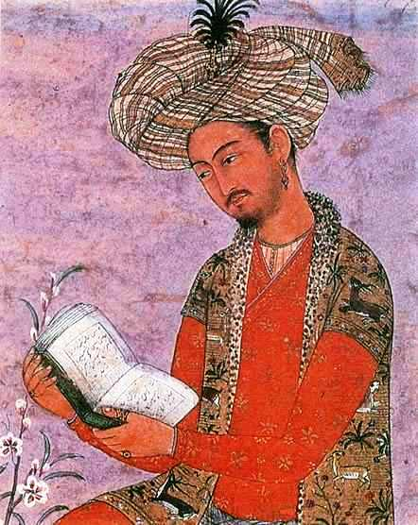

Class Schedule

Unit 1: Introduction

Mon. (6/29): CLASS INTRODUCTION

Tues. (6/30): LECTURE—"What is the West?"
Martin Lewis and Karen Wigen, The Myth of Continents: A Critique of Cartography, ch. 2, "The Spatial Constructs of Orient and Occident, East and West; The Shifting Boundaries of East and West," pp. 49-63. (on reserve)

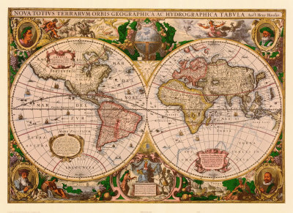

Unit 2: To the Starting Line

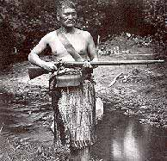

Weds. (7/1):
Jarett Diamond's Guns Germs and Steel, pp. 33-82.
Adas, Machines as the Measure of Man, “Introduction,” pp. 1-17. (library on-line access)

Thurs. (7/2):
Jarett Diamond's Guns Germs and Steel, pp. 83-93, 176-191.

Discussion Questions (Due 9:00 pm, Weds., 7/1) (Remember, respond to only one)
- Jared Diamond argues that the roots of inequality reach back to the Neolithic. While the “proximate” causes relate to “guns, germs, and steel,” the “ultimate causes” are much more environmentally driven. How have the ecological limits placed on people, especially in farming and animal husbandry, profoundly affected world development?
- According to Diamond, why did Eurasia enjoy an advantage in both diffusion of agriculture and domestication of animals over Africa and the Americas? Please give several examples.
- Within Eurasia why has Western Europe enjoyed an important, though perhaps transitory, advantage in “guns, germs, and steel?” What do New Zealand’s Musket Wars tell us about innovation, technology and resource bases?
Fri. (7/3): NO CLASS—INDEPENDENCE DAY BREAK

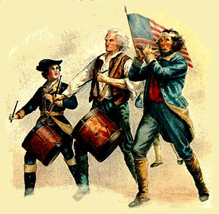

Unit 3: Before Western Hegemony

Mon. (7/6): LECTURE—"The Emergence of Europe"
Robert Bartlett, The Making of Europe, ch. 12, “The Political Sociology of Europe after the Expansion,” pp. 292-314.
Headrick, Power of Peoples, Ch. 1, "The Discovery of Oceans, to 1779," pp. 1-59.

Tues. (7/7): Wolfgang Schivelbusch, Tastes of Paradise, “Spices, or the Dawn of the Modern Age,” pp. 3-14.
Abu-Lugold, “The World System in the 13th Century: Dead-End or Precursor?” in Michael Adas, ed., Islamic and European Expansion: The Forging of a Global Order, pp. 75-102.
Kenneth Pomerantz, The Great Divergence, “Introduction,” pp 3-27;

Discussion Questions (Due 9:00 pm, Mon., 7/6)
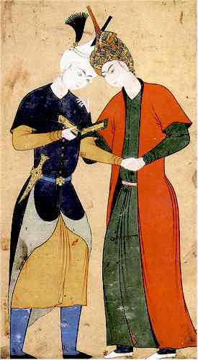
- Robert Bartlett argues that Europe came together as Europe in the high middle ages. What institutions and behaviors does he see as uniting “Europe” culturally, politically and socially? How do these institutions set the groundwork for later European expansion (pay special attention to European aristocracies rather than European states)?

- How, according to Headrick, did Europeans "discover" the ocean? How did they develop the technology to exploit maritime trade routes? Why were the Europeans more successful developing the "navigation revolution” than other civilizations?

- How do Abu-Lugold and Schivelbusch discuss the world trading system in the Middle Ages. How were Europeans, whom Schivelbusch considers a "dependent" and "backwoods, agrarian civilization," attracted to this world trading system by "tastes of paradise"? How did the crisis of this world economy following the collapse of the Mongol Empire and the Black Death, according to Abu-Lugold, open opportunities for the Europeans?

Unit 4: First Contact
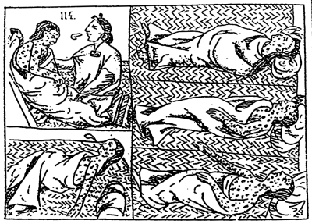

Weds. (7/8): LECTURE—"The Columbian Exchange"
Crosby, The Columbian Exchange, ch. 5, “New World Crops and Old World Demography,” pp. 165-208. (on reserve)
Headrick, Power of Peoples, Ch. 3, "Horses, Diseases, and the Conquest of the Americas, 1492-1849," pp. 95-138.

Thurs. (7/9): Jarett Diamond's Guns Germs and Steel, pp. 67-82, 195-215, 355-375

Discussion Questions (Due 9:00 pm, Weds., 7/8)
- What was the “Columbian Exchange?” Why did the Americas prove so hospitable to Old World germs, crops and animals? Who was the real conqueror of the Americas, the conquistadors or smallpox, the horse and sugar? Why does Headrick point out that the Europeans were not invincible?
- How did the American contribution to the Old World, especially of new crops, guarantee population growth there just as the New World faced apocalypse? How did the humble potato (as well as manioc, maize and sweet potatoes) help create a basis for urbanization and the industrial revolution?

Unit 5: Europe’s Scientific Revolution and the Dar es Islam

Fri. (7/10): LECTURE—"Gunpowder Empires and Islam"
William McNeil, “The Age of Gunpowder Empires, 1450-1800,” in Michael Adas, ed., Islamic and European Expansion; The Forging of a Global Order, pp. 103-140.
Headrick, Power of Peoples, Ch. 2, "Eastern Ocean Empires, 1497-1700," pp. 59-94.

Mon. (7/13):
Bernard Lewis, Islam and the West, ch. 1, “Europe and Islam,” pp. 3-42.
Ogier Ghiselin de Busbecq, “The Turkish Letters, 1555-1562”, Modern History Sourcebook.

Discussion Questions (Due 9:00 pm, Sun., 7/12)
- Where some emphasize the isolation of Islam from the West, McNeil notes that Muslim powers such as the Ottomans were as quick to seize on the gunpowder revolution as the West. What were the consequences of this embrace of technology? Does Busbecq’s description of the Turks lend support to the idea that the Turks were technologically inferior and economically backward compared to the West?
- Lewis argues that Islam largely ignored Europe and that led to its slow intellectual, economic and finally military decline. Headrick, however, points out that the Ottomans did counter-attack the Portuguese in the “narrow seas” effectively. Do you think Headrick’s account meshes with Lewis or is there a tension?

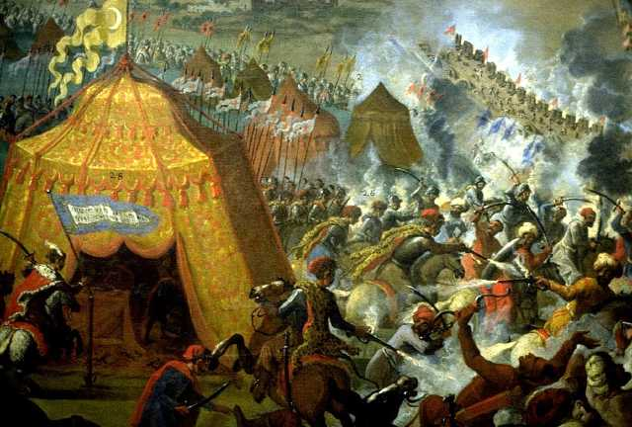
Unit 6: Mercantilism, Markets and Modernity: Rise of the West? ‘Fall’ of the East

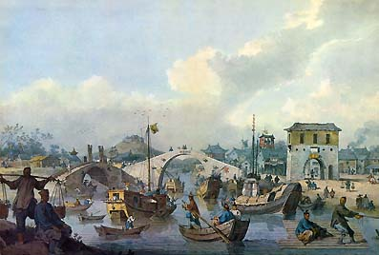

Tues (7/14): LECTURE—"East Asia Turns Inward"
Kenneth Pomeranz, “Political Economy and Ecology on the Eve of Industrialization: Europe, China and the Global Conjunction,” The American Historical Review, 107 (April 2002): 425-446.
Emperor Qian Long [Ch'ien Lung] (b.1711-1799, r.1736-1796), Letter to George III, 1793.
Weds. (7/15):
Headrick, Power of Peoples, Ch. 4, "The Limits of the Old Imperialism: Africa and Asia to 1859," pp. 139-176.

Discussion Questions (Due 9:00 pm, Tues., 7/14)
- Pomerantz argues that the early modern world economy was one of “multiple cores and shared constraints.” What did Europe and China share in common prior to the industrial revolution? Headrick notes that prior to the Industrial Revolution (and despite some spectacular results in India), European Empires found their conquests, even among militarily inferior societies such as those in the Caucasus, Afghanistan and Algeria, much more difficult to accomplish. Could it be that stable and powerful polities such as China really were at rough parity with the West in the early 19th century?
- What tone does the Chinese Emperor take with King George III of Britain? Does he show any cognizance of Britain’s emerging role as an economic and military superpower? Why is he indifferent to British entreaties for trade and political relations?

Unit 7: Enlightenment and Slavery—the Triangle Trade

Thurs. (7/16): LECTURE—"The Creation of the Atlantic World and the Plantation Complex"
Philip Curtin, The Rise and Fall of the Plantation Complex: Essays in Atlantic History, chs. 2, 4, pp. 17-28, 46-57.
Oladuah Equiano, The Life of Gustavus Vassa, ch. 2, “The Atlantic Voyage;”

Fri. (7/17):
Philip Curtin, The Rise and Fall of the Plantation Complex: Essays in Atlantic History, chs. 6, 12-13, pp. 73-85, 158-188.
David Eltis, Tables from “The Volume and Structure of the Transatlantic Slave Trade: A Reassessment,” The William and Mary Quarterly, 63/1 (2001): 17-46.

Discussion Questions (Due 9:00 pm, Thurs., 7/16)
- Describe the scope and experience of the Atlantic slave trade. How did the "sugar revolution" and the slave trade fundamentally transform the New World as well as deeply demoralize its victims? (you will want to reference Equiano as well as Eltis here)
- How was abolition integrally linked to both the rise of the Atlantic “liberal revolutions” and how did slavery show the limits of the Enlightenment and liberalism?

TAKE-HOME MID-TERM ESSAY EXAM HANDED OUT

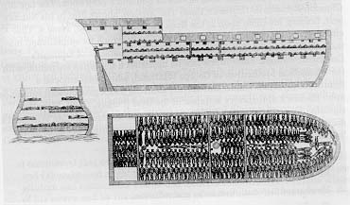

Unit 8: Industrialization and the Opium War

Mon. (7/20): LECTURE—"The Industrial Revolution and Free Trade"
Headrick, Power of Peoples, Ch. 5, "Steamboat Imperialism, 1807-1898," pp. 177-225.
Commissioner Lin, Letter to Queen Victoria, 1839;

TAKE-HOME MID-TERM ESSAY DUE BY BLACKBOARD SAFE-ASSIGN BY 10:00 am

Tues. (7/21):
Mike Davies, Late Victorian Holocausts; El Nino Famines and the Making of the Third World, ch. 1, “Victoria’s Ghosts” pp. 25-61 & ch. 11, “China; Mandates Revoked,” pp. 341-376. (on-line access)
The People of Canton, Against the English, 1842.

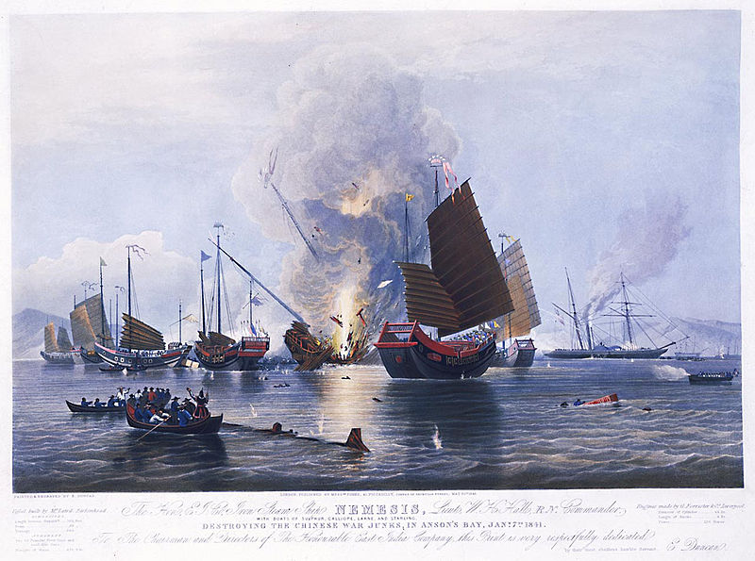

Discussion Questions (Due 9:00 pm, Mon., 7/19):
- Explain the role of the Industrial Revolution in cementing European military dominance? How was it possible for tiny Britain to humbling mighty China? (Headrick helps here). What was the Chinese response, both elite and popular, to the humiliation and intrusion of the Opium War?
- The people of Canton responded to the surrender of Chinese sovereignty not as some enlightened episode of freeing them from an oppressive and stagnant autocracy but with xenophobic fury barely concealing their opinion that the Westerners were barbarians. Given the economic regime imposed on China and most of the non-European war that Davies chronicles (he calls this the creation of the Third World), were the good citizens of Canton wrong for seeing the imposition of “free trade” and extra-territoriality as predatory?

Unit 9: The “New” Imperialism

Weds. (7/22): LECTURE—"The New Imperialism"
Headrick, Power of Peoples, Ch. 6, "Health, Medicine, and the New Imperialism, 1830-1914,"pp. 226-256 & Ch. 7, "Weapons and Colonial Wars, 1830-1914," pp. 257-302.
Thurs. (7/23):
Adam Hochschild, King Leopold’s Ghost, introduction, prologue, chs. 3-5, pp. 1-20, 47-88
Theories of Imperialism:
J. A. Hobson, selection from Imperialism (1902).
Joseph Schumpeter, selection from The Sociology of Imperialism (1918).
Rudyard Kipling, The White Man's Burden. (1899)
V. I. Lenin, “Imperialism and State and Revolution,” from Classics of Western Culture, ed. Knoebel, pp. 577-582.

Fri. (7/24):
Reading: Adam Hochschild, King Leopold’s Ghost, chs. 8-11 pp. 115-181;

Discussion Questions (Due 9:00 pm, Thurs., 7/23):
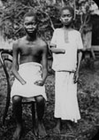
- Hobson found the “taproot” of Imperialism in economic protectionism, but Schumpeter argues that imperialism is, in fact, an avatar of the old absolutist state and economically retrograde. Lenin, on the other hand, argues that imperialist predation is the "highest stage of capitalism." Given the actions of Leopold in Congo, whose argument, if any, seems most compelling to you? Is it possible that European imperialism represents both a throw-back to earlier types of social control (say the plantation complex) and the most advanced form of economic exploitation?

- Kipling argues that imperialism is a moral imperative of the more dominant Europeans over other peoples, “half Devil, half child.” Leaving aside the profoundly racist foundations of this appeal, was it really the missionary impulse of European civilization that led to expansion in the tropics, or was it technological advances in medicine and weaponry, as Headrick observes. If Kipling thinks the logic of empire is "the white man's burden," Hilaire Belloc was rather more cynical in his poetry: "Whatever happens, we have got/The Maxim gun, and they have not." Who do you think is right, Kipling or Belloc?

Unit 10: Western Hegemony Challenged

Mon. (7/27): LECTURE—"The Interwar "Decline" of the West"
Headrick, Power of Peoples, Ch. 8, "The Age of Air Control, 1911-1936," pp. 302-333.
George Orwell, "Shooting an Elephant" in Collected Essays, pp. 15-23.

Tues. (7/28): Ian Buruma and Avishai Margalit, Occidentalism: The West in the Eyes of Its Enemies, ch. 1, “War against the West,” pp. 1-13.
Critics of Western Dominance:
Baku Congress of Toilers of the East (Bolsheviks), Appeal of the Congress of the Peoples of the East to the Workers of Europe, America and Japan.
Deepika Bahri, The Salt March to Dandi.
“Tojo Greets the East Asia Prosperity Conference,” in Japan's Greater East Asia Co-Prosperity Sphere in World War II: Selected Readings and Documents, pp. 88-93.

Discussion Questions (Due 9:00 pm, Mon., 7/27):
- The Communists, Gandhi and Tojo all saw Western dominance based on material, not cultural or political foundations. Of course each had very different prescriptions for their anti-imperialism (class war, non-violent resistance, militarism). Nonetheless, what do they take for granted when talking about the West? What do they differ on? Do these views all fit into an over-arching ideology of "occidentalism"?

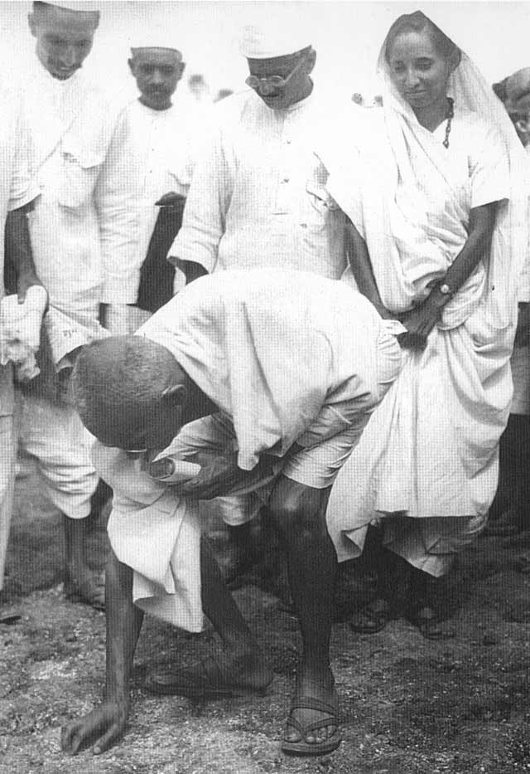
- Unlike anti-imperialists, Europeans themselves tended to account for their global hegemony in terms of cultural superiority, by their “civilizing mission.” How did the Great War and the rise of fascism undermine this cultural confidence? How did the reliance on air bombing campaigns create a sense of moral revulsion towards imperial control? Why did some intellectuals, such as Orwell, argue that Europeans’ self-image was a farce that damaged native societies? Why did Orwell shoot the elephant?

Unit 11: Cold War and Decolonization

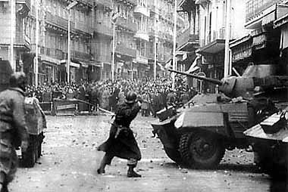

Weds. (7/29): LECTURE—"The Cold War and the End of European Empire"
Headrick, Power of Peoples, Ch. 9, "The Decline of Air Control, 1946-2007," pp. 334-374.
Lim, Richard and Smith, David, eds., The West in the Wider World, ch. 13, “The Call for Liberation in the Era of Cold War,” (Congo, Algeria) pp. 325-351 (especially Kuznetsov, Cabot Lodge, Lumumba, Camus, Taleb-Ibrahimi).

Thurs. (7/30):
The film, The Battle of Algiers, on reserve, to be seen independently prior to class.
“An Interview with Gillo Pontecorvo,” Film Quarterly, 26/1 (Autumn, 1972): 2-10.

Discussion Questions (Due 9:00 pm, Wedn. 7/29):
- Where Western powers resisted decolonization the result was often, as in Algeria, as the great historian Eric Hobsbawm noted, “a conflict of particular brutality, which helped to institutionalize torture in the armies, police and security forces of countries that purported to be civilized.” The Battle of Algiers clearly shows that using such tactics allowed the Europeans to “win” the battle, but of course at the cost of losing the war. Why did European powers with overwhelming military advantage (such as the French in Algeria, the Soviets in Afghanistan and the U.S. in Vietnam) fail in the face of colonial insurgency? You should certainly reference Headrick in this answer.

- The Cold War was an important aspect of decolonization. It is arguable whether the U.S. would have committed to fighting in Vietnam or the British to engage in the long Malaysian anti-insurgency had their opponents not been Communists. Looking at the events in the Congo, how did its decolonization get caught up in Cold War rivalries, and to what end?

Unit 12: After the Cold War
Fri. (7/31): LECTURE—"The End of the Cold War and the Legacy of Empire"
“Is Western Civilization in Decline,” (Fukiyama vs. Huntington) in Taking Sides, pp. 448-467.
Gourevitch, We wish to inform you that tomorrow we will be killed with our families…”, chs. 1 & 7, pp. 15-24, 85-110.

TAKE-HOME FINAL ESSAY EXAM HANDED OUT

Mon. (8/3):
Gourevitch, We wish to inform you that tomorrow we will be killed with our families…,” chs. 8-11, pp. 101-171.

Discussion Questions (Due 9:00 pm, Sun., 8/2):
- Fukiyuma believes the fall of the Soviet Union proves that only the Western model is successful as a form of modern civilization. Huntingdon demurs and considers that other civilizations not only exist—some which explicitly reject European modernity—but will resist any fusion into a new “global” culture? Who do you think is right? Either? Neither? Both? What is the fate of Western Civilization?

- Does the Rwanda genocide support Fukiyama’s insistence on necessity of Western liberal institutions or Huntington’s view of warring tribes? How does the complete indifference of the West to this horror, one with deep roots in European imperialism, undercut or support their arguments?

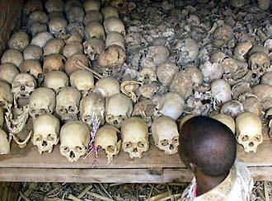

Unit 13: Globalization and its Discontents

Tues. (8/4): Benjamin Barber, "Jihad vs. McWorld," The Atlantic (March 1992).

Weds. (8/5): Niall Ferguson, Civilization: The West and the Rest, "Conclusion: The Rivals," pp. 295-326.

Discussion Question (Due 9:00 pm, Tues., 8/5):
- Barber and Ferguson both see the West and its dominant ideology of liberalism as under threat. While each has a very different view of what is at root of this malaise (for Barber it is the rise of stateless corporate power and xenophobic particularism in a globalized economy; for Ferguson the reassertion of China's place in the world order as an authoritarian capitalist power), but each seems sure the West's half millennium-long stretch of global dominance is in decline. After the events of September 11, 2001 and the Great Recession of 2008-2010, do you think the pessimists may be right?

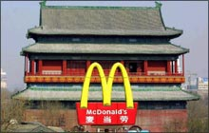

Finals

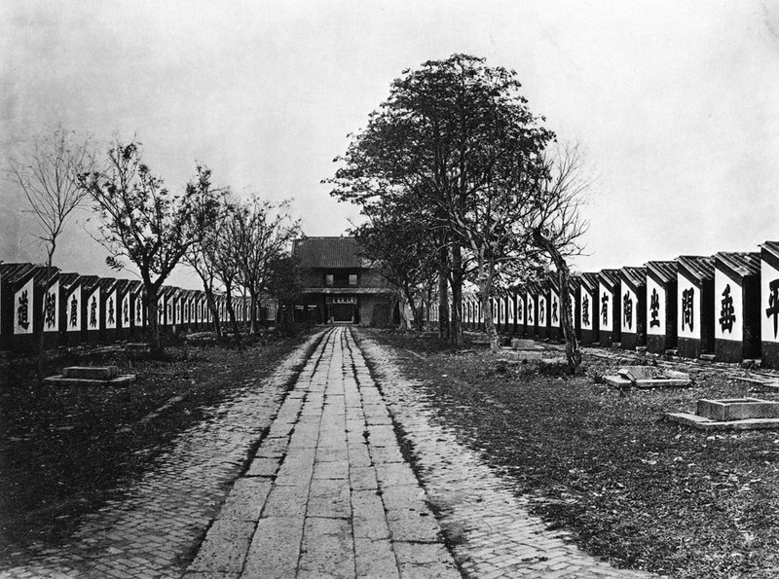
Tuesday, April 30, Optional Review Session

Friday, August 7th
Take-Home Final Exam submitted on blackboard safe-assign by 11:00 am !!!!!!

NO EXTENSIONS WILL BE ALLOWED FOR ANY REASON

